

**Nebraska On-Farm Research Network**

**Corn CRM Hybrids for Improving Cover Crop Establishment**

*Protocol developed by: Dr. Chris Proctor - Weed Management Extension Educator, Dr. Justin McMechan – Crop Protection and Cropping Systems, Dr. Roger Elmore - Extension Cropping Systems Agronomist, Angela Bastidas - Graduate Research Assistant; UNL Agronomy & Horticulture*

**Objective:** Identify the actual on-farm yield of four different comparative relative maturity (CRM) corn hybrids.

**Rationale:** Cover crops have the potential to provide several ecosystem services, which is why more corn producers are finding ways to integrate them into their cropping systems. One of the primary limitations to fall planted cover crops in Nebraska is the limited growing window following corn. Recent small plot research at the University of Nebraska found that shorter season comparative relative maturity (CRM) (95 CRM) corn hybrids have similar yields to longer season CRM hybrids (111 CRM) (Figs 1&2). This research also showed the potential for greater cereal rye biomass accumulation following the 95 CRM hybrid compared to the 111 CRM hybrid (Figs 3&4). Based on these results our objective is to evaluate corn growth, development, and yield results for different CRM hybrids using on-farm research. Our sub-objective is to track development stages of the differing hybrids at these different locations to help us understand why yield differences do or do not occur among this wide range of CRM hybrids. Results from this research would allow us to provide more confident recommendations to Nebraska corn growers about the yield potential of shorter season CRM hybrids. In addition, this information could help improve the possible benefits from fall planted cover crops following corn.

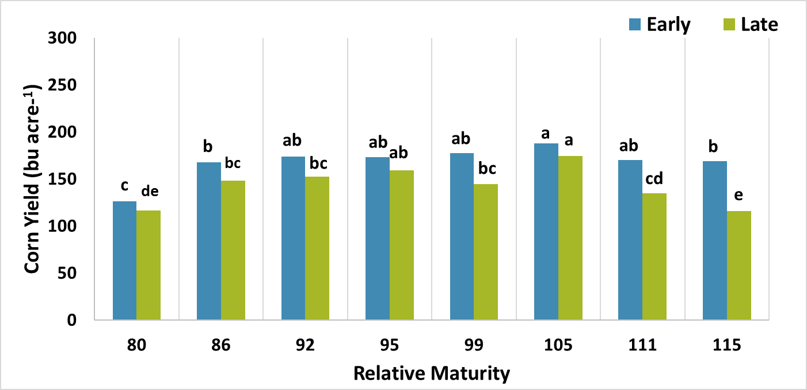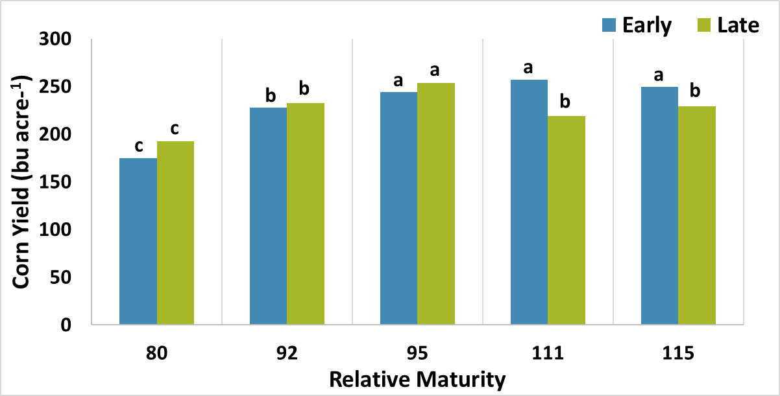

Fig 2. Corn yield as affected by planting date and relative maturity at SCAL (irrigated, near Clay Center) across both years (2015 & 2016). Bars with the same letter(s) within same planting date are not different (Significant at P ≤ 0.05).

Fig 1. Corn yield as affected by planting date and relative maturity at Havelock (rain-fed, Northeast side of Lincoln) in 2016. Bars with the same letter(s) are not different (Significant at P ≤ 0.05).



Figure 4. 2015 fall biomass production as affected by the planting date at SCAL (irrigated) and estimated corn RM harvest maturities. Bars with the same letter(s) are not different (Significant at P ≤ 0.05). Sampling date: 11/15/2016 (Year 2).

Figure 3. 2015 fall and 2016 spring biomass production as affected by the planting date at SCAL (irrigated) and estimated corn RM harvest maturities. Bars with the same letter(s) within same sampling are not different (Significant at P ≤ 0.05). Sampling dates: 12/08/2015 and 04/14/2016.

**Procedure:** To determine the actual yield of different CRM corn hybrids we suggest that four CRM hybrids be tested. These will be replicated in the field and, ideally evaluated over multiple years.

The following corn CRM hybrids will be provided, however, participants may choose to add their own hybrids in addition.

|  |  |
| --- | --- |
| **Hybrids provided by On-Farm Research** | |
| **CRM** | **Description** |
| 95 days | DKC 45-65 RIB (GENSS RIB) |
| 105 days | DKC 55-20 RIB (GENSS RIB) |
| 111 days | DKC61-54RIB (GENSS RIB) |
| 115 days | 215-83STXRIB (GENSSRIB) |

Below is a list of proposed on-farm research locations.

|  |
| --- |
| **Location** |
| Rainfed/dryland West of Hwy 281 Rainfed/dryland East of Hwy 281 Irrigated option 1 (all locations) Irrigated option 2 (all locations) |
|
|
|

**Treatment Design:** The following is the treatment design for a four hybrid trial. At least 4 replications are needed for this trial. The same management practices should be used across the entire study area.

**NOTE:** Rows planted in each treatment need to be equal to or greater than corn head width.

|  |  |  |
| --- | --- | --- |
| Replication 1 | Hybrid 1 | Yield: |
| Hybrid 2 | Yield: |
| Hybrid 3 | Yield: |
| Hybrid 4 | Yield: |
| Replication 2 | Hybrid 2 | Yield: |
| Hybrid 4 | Yield: |
| Hybrid 3 | Yield: |
| Hybrid 1 | Yield: |
| Replication 3 | Hybrid 2 | Yield: |
| Hybrid 1 | Yield: |
| Hybrid 4 | Yield: |
| Hybrid 3 | Yield: |
| Replication 4 | Hybrid 3 | Yield: |
| Hybrid 1 | Yield: |
| Hybrid 2 | Yield: |
| Hybrid  4 | Yield: |

*Grower Requirements:*

1. Flag or mark GPS location of each treatment.
2. Provide all necessary inputs for crop production.
3. Complete background agronomic form about site and practices.
4. Collect yield data and grain moisture with weigh wagon or yield monitor. If using yield monitor, please designate a separate “load” for each treatment and set up separate “product” names for each treatment harvested. Yield monitor must be **well calibrated**. Contact UNL Extension if assistance with this process is needed.
5. Collect stand counts at harvest.
6. Submit harvest data to UNL Extension within 30 days of harvest or by Dec. 15.
7. Allow UNL Extension to use submitted and collected data for research, educational, and informational purposes.

*Nebraska On-Farm Research Network will:*

1. Provide one unit (80,000 kernels) of seed for each of the four CRM corn hybrids.
2. Provide technical assistance in setting up replicated and randomized experimental design.
3. Provide assistance upon request with treatment implementation, flagging, stand counts, and recording yield.
4. Analyze raw data using statistical analysis and provide this information to the grower.

**Disclaimer:** The Nebraska On-Farm Research Network does not endorse the use of products tested in on-farm replicated strip trials. While treatments are replicated within trials and may be replicated across multiple sites under various conditions, your individual results may vary.

*Copyright ©2015*

Extension is a Division of the Institute of Agriculture and Natural Resources at the University of Nebraska–Lincoln cooperating with the Counties and the United States Department of Agriculture.

University of Nebraska–Lincoln Extension educational programs abide with the nondiscrimination policies of the University of Nebraska–Lincoln and the United States Department of Agriculture.