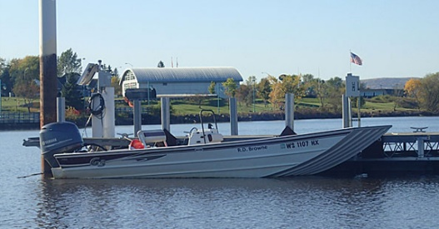
Request for Use of Lake Superior Reserve’s
RD Browne

General information:
- This vessel requires 1 Reserve operator.
- This vessel can support missions pertaining to research and monitoring in the St Louis River, the estuary, and other shallow waters and can be trailered.
- Fees may be charged for use of this vessel.

To apply for use of this vessel, please provide the following information:

1. Name of person(s) requesting use, institutional affiliation, email and phone number.

2. Dates requested.

3. Short description of proposed mission (research, monitoring, education).

4. General locations for planned mission.

5. Number of crew participants expected / required.

