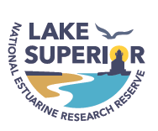
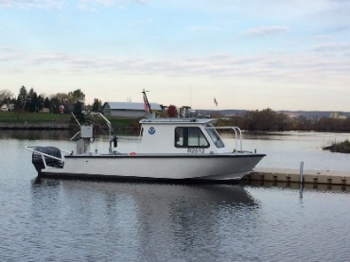
Request for Use of Lake Superior Reserve’s
NOAA Vessel R2512

General information:
- This vessel is NOAA property and requires 2 certified NOAA operators for any mission.
- This vessel can support missions pertaining to research, monitoring or education in the St Louis River, the estuary or Lake Superior up to 12 miles off shore.
- Use of this vessel must comply with all NOAA risk management procedures.
- Fees may be charged for use of this vessel.

To apply for use of this vessel, please provide the following information:

1. Name of person(s) requesting use, institutional affiliation, email and phone number.

2. Dates requested.

3. Short description of proposed mission (research, monitoring, education).

4. General locations for planned mission.

5. Number of crew participants expected / required.

